Explanation
- The light intensity from space objects follows a Gaussian distribution
  - As you move away from the bright center, it gets dimmed out
  - This results in “smearing” the light

- Observatories often take measurements of this “smear”
  - For stellar object tracking (stars, satellites, etc), you want to minimize smear
  - This smear is referred to as Full Width Half Max (FWHM), measured in arc seconds
  - Higher FWHM measurements means more smear or blur in the light

- Visualization:
  - Smaller FWHM = Less smearing
  - Larger FWHM = More smearing
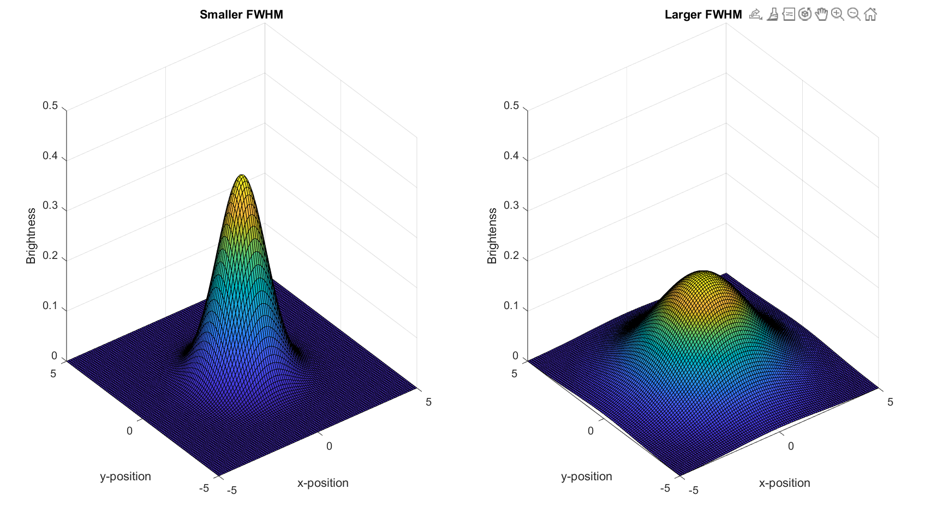

- To change FWHM into a more familiar unit of spreadiness, I converted FWHM into standard deviation, 𝜎
  - For the sake of making things easier to think about, let’s call this a “blur unit”
  - FWHM = 2.355𝜎
  - CAREFULLY NOTE: ALL THE PAPERS IN DOCUMENTATION USE FWHM, NOT STANDARD DEVIATION

- We will use 𝜎 to express how much uncertainty we have in elevation and azimuth measurements.
  - Gaussian distributions in spherical trig are a lot harder, but let us use the small angle approximation (angles on the order of arc seconds)
  - Example: We record
    - an azimuth of 40°
    - an elevation of 50°
    - a blur unit of 1 arcsecond
  - Then, we have this:
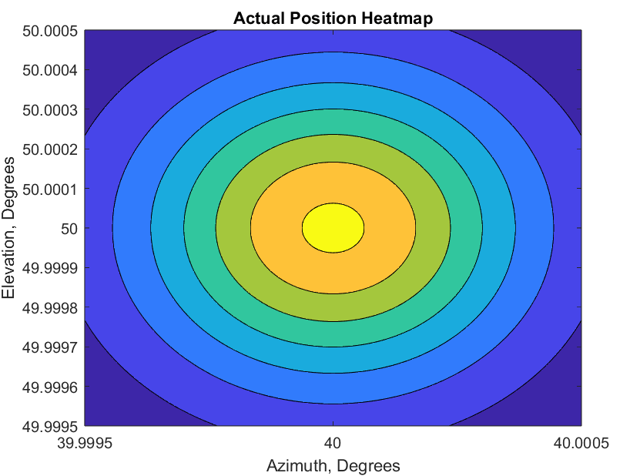

- Imagine the satellite is at 40° azimuth, 50° elevation. We have “an idea” of where it actually is
- Yellow/orange is higher probability
- Blue is lower probability
- We sample from this Gaussian
- The blur unit for a particular measurement is extremely dependent on atmospheric conditions and can vary widely

Results
- After examining FWHM data from various observatories, I have created the following:
  - A percentile chart
  - General heuristics
  - BE CAREFUL: ALL THESE MEASUREMENTS ARE IN ARCSECONDS, NOT DEGREES
    - 1° = 3600 arcseconds

Percentile Chart
- Below is a chart aggregating 518,092 measurements from Muztagh-ata Site II and Lijiang Observatories.
- This is not a complete representation of realistic measurements (you need weather data from everywhere), but it is a good start
- Referencing the below chart:
  - 25th Accumulation: A blur unit of 0.30 arc seconds is worse than 25% of all measurements; better than 75% of all measurements
  - 50th Accumulation: A blur unit of 0.375 arc seconds is “typical” (median)
  - 75th Accumulation: A blur unit of 0.4875 arc seconds is worse than 75% of all measurements; better than 25% of all measurements
    - On a “bad day”, the blur unit is 0.4875 arc seconds
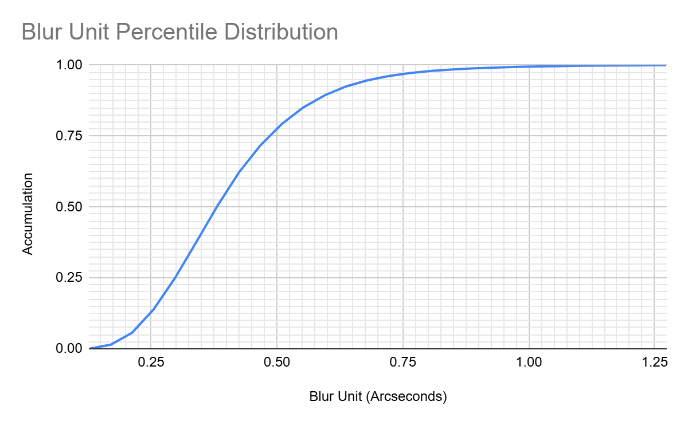
General Heuristics

- It appears that the “best reasonable” blur unit is 0.25 arcseconds
  - Context: Taken at Maidanek Observatory

- Observations at Cello Chico, Cello Toco sites in Atacama, Chile suggests that about 0.28 to 0.40 arcseconds are easily doable

- I found that the worst recorded blur unit is 1.32 arcseconds
  - Context: Taken at Antarctic stations

- Some Figures To Run With
  - Good Day: A blur unit of ~0.3000 arc seconds (better than 75% of days)
  - An OK Day: A blur unit of ~0.3750 arc seconds (better than 50% of days)
  - A Bad Day: A blur unit of ~0.4875 arc seconds (worse than 75% of days)
  - A REALLY Bad Day: A blur unit of ~0.7000 arc seconds (worse than 90% of days)

- Results taken from Antarctic Stations, Atacama, Lijiang, Muztagh-ata, Maidenak, and Xinglong all show that the mean blur unit is much worse than the median blur unit
  - Essentially, most days are good
  - But when it gets bad, it gets bad
  - The FWHM distribution for Lijiang is shown below. It is noticeably skew right

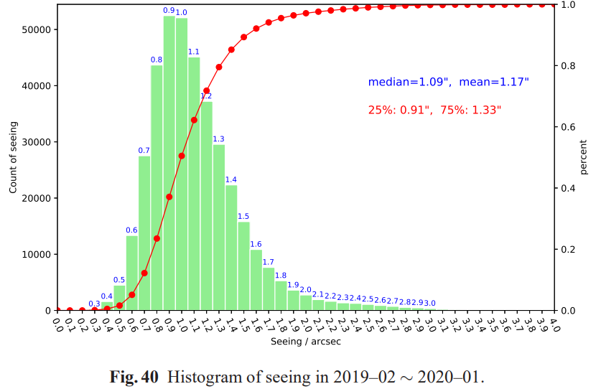

Documentation
- Measurement of optical seeing on the high antarctic plateau
- Simultaneous seeing measurements at Atacama
- Astronomical Site Monitoring System at Lijiang Observatory
- Site testing at Muztagh-ata site II: seeing statistics
- Astronomical Seeing and Meteorological Parameters at Maidanak Observatory
- Astronomical Observing Conditions at Xinglong Observatory from 2007 to 2014

